## **Modelling approaches**

The term “model” has multiple potential definitions, but in the context of mental health systems, it is typically used to refer to a mathematical representation of phenomena relevant to the decision making of mental health policymakers and service planners. The main purpose of a model is to make predictions – i.e., to estimate something that is unobservable. When a prediction relates to future events, it can be called a forecast.

Compared to traditional methods based on combining historical service usage with budgetary adjustments, systems models allow a greater range of relevant sociotechnical factors to inform mental health service planning and policy development. Mental health systems models typically synthesise a range of data on demography, epidemiology, services and other social, economic and community infrastructure to predict the likely demand for healthcare (e.g., in the future, under counterfactual scenarios or in response to a shock). Moreover, these models can be used to explore the potential impacts, costs, equity implications, implementation challenges and an optimal configuration of proposed responses to healthcare demand.

As the name suggests, systems models are designed to help decision-makers take a more holistic perspective, with one approach being to explore healthcare as ecosystems of interdependent services, service users and health professionals [REF]. Practical benefits of the more expansive nature of systems modelling include decision aids to help anticipate the accumulation of downstream consequences of isolated actions that may merely defer problems or displace them to other parts of the system. Similarly, mental health systems models may be particularly useful for supporting regional planning initiatives that account for the unique needs and characteristics of an area of interest.

Some types of models allow for the system they represent to change over time (“dynamic” models), while others are based on a simplifying assumption that the systems they describe are static. Models can be designed to either be deterministic or stochastic. Deterministic models make fixed predictions determined by non-random parameters, are relatively simpler to implement and allow for limited exploration of the uncertainty of predictions (e.g., through use of alternative input parameter values). Stochastic models, on the other hand, use random input parameters to generate a range of values that provide a more extensive description of the uncertainty of predictions.

Mental health systems are very complex and any individual model will typically focus on representing only a simplified subset of system features that are most relevant to the decision topic being explored. The identification of salient system features will in turn shape the type of modelling technique to be deployed, with different methods indicated depending on whether the features of primary interest are trends, health states, flows, service processes, relationships, or system resources. Some of the different types of models that have been developed and applied to forecast, evaluate and optimise mental health services (1) are identified in Figure 1. These models vary in mathematical/statistical design, purpose and complexity.

Statistical learning models (e.g., time series forecasting models, spatio-temporal models, causal models) are statistical tools to learn patterns in historical data (e.g., trends, distributions, and associations) to be able to predict possible future or trends under counterfactual conditions. They are data-driven and are commonly used to estimate and forecast the spatial and/or temporal distribution of illness prevalence, incidences and demands (2) or dynamics between services (3). They rely on an assumption that the predictions are determined by structure in existing data (e.g., historical trends, causal associations between variables). In mental health research, they are increasingly used to explore large datasets for purposes that include risk prediction, targeting care and identifying potential targets for prevention and intervention.

Needs-based planning models build on such projections of future population prevalence by also modelling the quantum and types of services required to respond to these needs to estimate the system resourcing needed, such as workforce, facilities and funding [REF]. A prominent Australian example of a needs based planning model is the National Mental Health Planning Framework Tool [REF].

Markov model (MM) is a general term for a group of models (also called state-transition models) that predict transitions between different states (e.g. healthy, sick, recovered, dead). The states in a Markov model can be observed or latent and transitions between them are governed by the Markov assumption that the system is "memoryless", with transition probabilities solely depending on the present state and not the past. MM can be modelled both at the aggregate (cohort) or individual level with transition probability either being estimated from data or assumed based on literature or empirical evidence (4). MMs are widely used in service planning and health economic evaluation (e.g., to compare treatments) (1), due in part to their relative simplicity in modelling the outcomes of different courses of action over time. Markov models are the most common type of mental health simulation model, though over recent years there has been a shift to other methods as the mental health modelling field has matured (REF).

System dynamics (SD) models (or compartment models) try to capture flows of population aggregates (e.g., how the totals for each age or service engagement sub-group within a population change over time). SD models are not restricted by the memoryless assumptions of MM, thereby allowing for interdependencies, feedback and complex designs in the system (5). As the outputs generated by SD models depend on their feedback structure, these models can require significant investment in conceptualisation and validation. Historically, SD models were commonly used in disease epidemiology, and in recent years, they have been increasingly used in health system research (6). The main application of system dynamics models in mental health to date has been to examine topics in health system operations like patient flows [REF].

Discrete Event Simulation (DES) is an individual-based method focusing on modelling the timing and impacts of events occurring in system processes. In health system research, DES offers a flexible tool to model patient pathways through care and identify ways to optimise resources (7). It is particularly well suited to describing resource constrained systems, where events (e.g., contact with a service) occur at discrete points of time and entities (e.g. patients) move through a system of queues with events and wait times governed by probability distributions and the availability of resources (e.g. clinicians). About one in ten mental health simulation studies use DES, with epidemiology and economic evaluation studies the most common purpose [REF].

Agent-based models (ABMs) simulate the behaviours of individual agents (e.g., patients, health care providers) and their interactions with other agents and their environment. Compared to other techniques, ABM offers additional flexibility to model complex behaviours and interactions, as well as learning and adaptation (8). Both ABM and DES models can be major undertakings to implement and validate given both their inherent complexity and detailed microdata requirements. This may be why they are undertaken less frequently than simpler approaches, although their popularity is growing. ABMs currently account for about one in twenty mental health models, with a particular focus on help-seeking and service access [  
REF].

As each model type has advantages and limitations, increasingly advanced computational technology can integrate two or more types of approaches, creating hybrid or blended models (9). Blended models can be designed in different ways – e.g., full integration, sequential design and hierarchical design (10, 11) with a general aim of taking advantage of multiple models to improve overall modelling performance. Alternatively, modelling results obtained from different methods or different modelling parameters can be ensembled (averaged) to obtain more reliable estimates. Ensemble modelling has been increasingly used in infectious disease forecasting (12, 13) and burden of disease modelling (14, 15), though is not yet common in mental health system simulation.

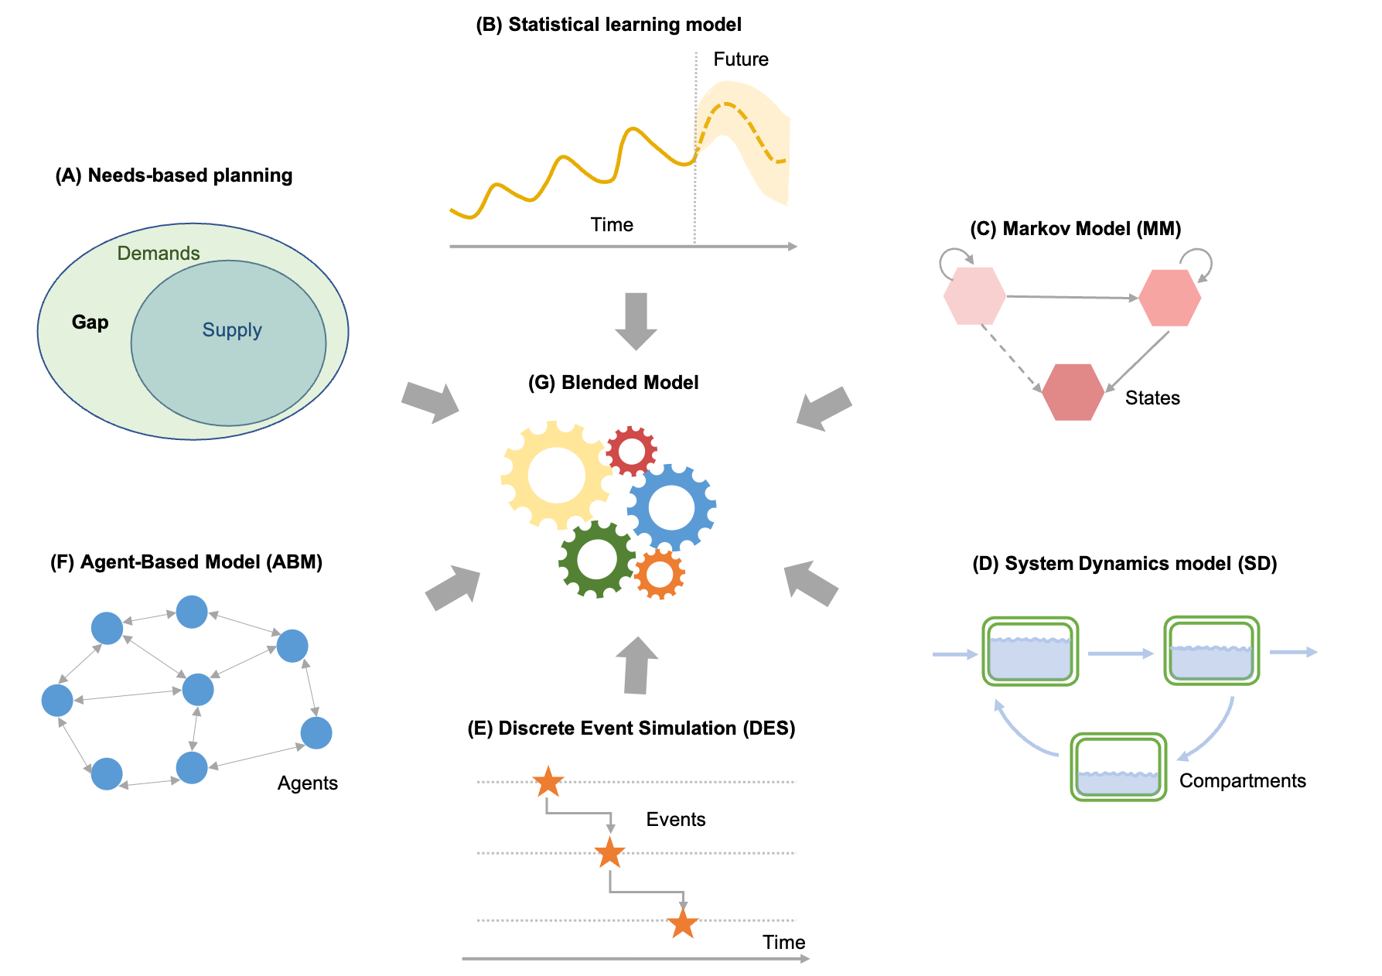

Figure 1. Different approaches for modelling mental health demands and systems. (A) Statistical learning models aim at exploring patterns in historical data to predict possible future or trends under counterfactual conditions; (B) Markov model (MM) simulates transitions between different health states over time; (C) System Dynamics model (SD) describes flows between different compartments (e.g., counts of people flowing from primary to tertiary care); (D) Discrete Event Simulation (DES) traces the timing and impact of events in processes; (E) Agent-based model (ABM) predicts the behaviours, interactions and adaptation of individual agents; (F) Blended (hybrid) model integrates different types of models.

Many factors will be taken into consideration when choosing appropriate models (s), such as modelling questions, available data, project life-cycle and available recourses, some of which are described in Table 1. Although these modelling frameworks differ, the successful implementation of health system models depends on a number of factors that are not related to the design and complexity of models, for example, appropriate co-design and engagement with stakeholders, reliable input data, robust validation processes and interactive toolkits (16).

Table 1 Comparisons between different modelling approaches

|  |  |  |
| --- | --- | --- |
| Model types | Common applications | Practical considerations |
| Statistical learning model | Epidemiology and service demand modelling | * Easy to implement and less computationally demanding * Require reliable historical data * Comparisons between alternative decisions or scenarios require the establishment of a reliable causal framework either from the data or literature. |
| Needs-based planning model | Service demand and resource requirements forecasting | * Can be easy to implement simple versions that are not computationally demanding, but more sophisticated implementations can be resource intensive, particularly in stakeholder engagement and validation * Require data on populations needs, best practice service responses, and models of service operation * Tend to include static assumptions about service delivery and may not capture complex system features such as interdependencies between services |
| Markov model (MM) | Policy / treatment evaluation | * Easy to implement and less computationally demanding * Require data for fewer parameters * Can be oversimplified and not capture important system features |
| System dynamic (SD) model | Epidemiology and policy / treatment evaluation | * Can be easy to implement simple versions that are not computationally demanding, but more sophisticated implementations can be resource intensive, particularly in stakeholder engagement and validation * Can model complex system features such as feedback loops * Require data for more parameters * Cannot model individual-level behaviour |
| Discrete Event Simulation (DES) | Service evaluation, service / system optimisation | * More time consuming to implement and more computationally demanding * Can model complex system features, most particularly the resource dependency and time to event in continuous time, thereby, particularly useful for optimisation tasks * Require data for more parameters that can be difficult to obtain |
| Agent-based model (ABM) | Demand forecasting, service / system optimisation and strategic foresight | * More time consuming to implement and more computationally demanding * Can model complex individual-level heterogeneities, behaviours and interactions and spatial / environmental attributes. * Require data for a large number of parameters that can be difficult to obtain |
| Blended model | Any of the above | * More time consuming to implement and can be more computationally demanding * Limitations of single models can be addressed with integration |

Regardless of which modelling technique is deployed, the process of developing a mental health systems model can be broadly described as follows:

**Define the research question** – develop a well-defined research question to guide the establishment of the modelling framework. The PICOT framework (patient, intervention, comparison, outcome and timing), although not designed specifically for health system simulation, can be used to guide this process.

**Model conceptualisation** – determine the model type(s) and structure that can best address the research question at hand. The development of a conceptual model is a critical step in model development for which best practice guidance is available (17). In this stage, a combination of literature reviewing and stakeholder engagement can be used to help identify the appropriate model(s). The final choice of model(s) depends on research questions as well as available resources and the project timeline. Then model structures will need to be established outlining the causal pathways between in-scope model parameters (e.g., events or health states), comparison framework and requirements in input data.

**Data collection** – identify, analyse and synthesise multiple sources of data using best practice methods. The required input data will need to be collected from different sources such as population epidemiology, service delivery data and relevant literature.

**Model implementation** – operationalise the model structure by incorporating all input data and programming the model. Best practice guidance on model implementation can vary based on the type of model (18-21). When multiple types of models are used, the results will need to be integrated.

**Model verification and validation** – perform checks on the model to ensure that the model functions correctly and that it produces results that are in keeping with reality. Best practice guidance on model verification and validation recommends steps that can include comparisons of model predictions to real-world data, the output of other models and the expectations and expertise of stakeholders (22-24).

**Model refinement** – refine the model based on the results of model testing and stakeholder feedback. Additional data may need to be collected if there is any extension of the modelling scopes.

**Feedback report/tools** – interpretation and collation of model findings in a format that is suitable for dissemination to policymakers and stakeholders. Interactive tool(s) can be developed, which can help non-technical users to apply the model and/or visualise results, thereby, improving translational impact.

**Application** – applying insights from modelling to guide changes in policy and service delivery. In this stage, the modeller can work collaboratively with stakeholders to design an implementation plan, for example, a prospective costing analysis under different roll-out scenarios. The impact of implementation on system operation can then be utilised to improve the design of the modelling framework to close the loop.

Regular engagement and consultation with stakeholders throughout the entire lifecycle of a modelling project can help ensure that the research question is appropriately defined and that any prospective model produces results that are valid and relevant. A co-design framework can be applied in some of the critical stages, for example, model conceptualisation and feedback report/tool(s) as described in Fig 2. Such collaborative approaches to model development and use may also serve an educational purpose for non-modellers, helping to improve mental models and the use of evidence in decision-making (25).

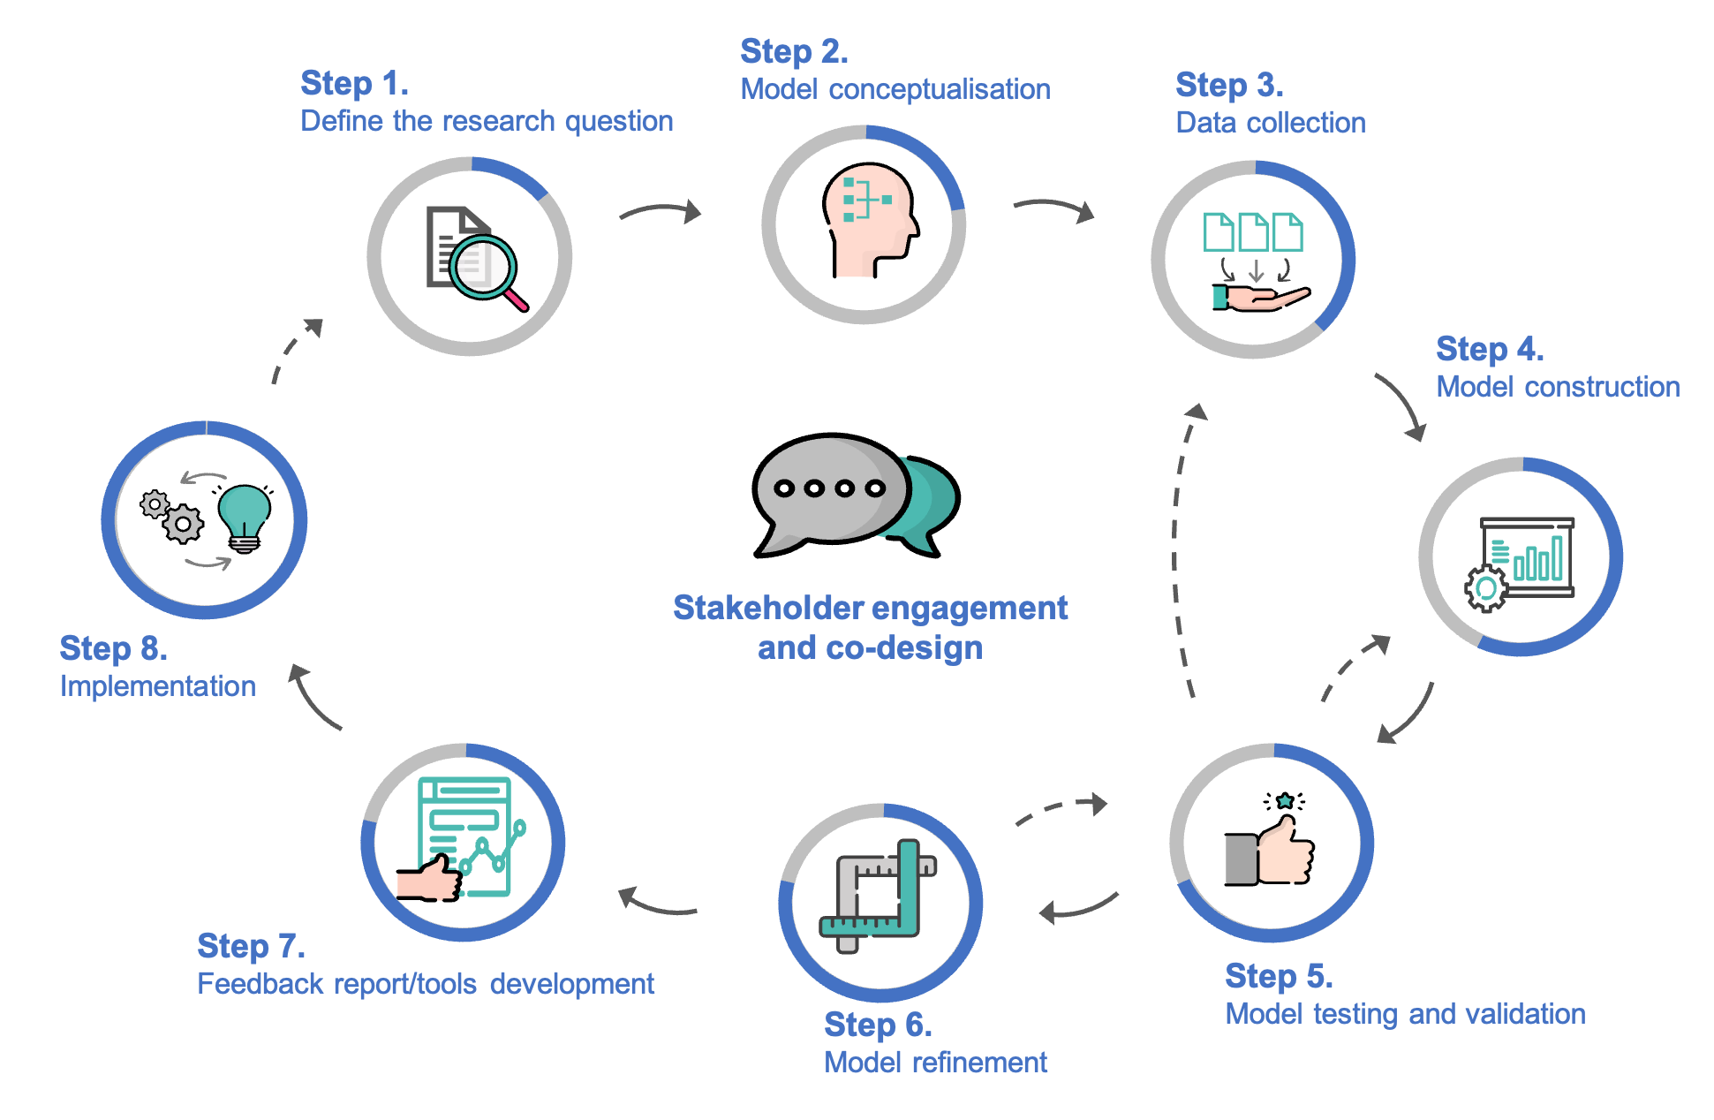

Figure 2. Lifecycle of the health system simulation projects

Finally, to be both trusted and trustworthy, models need to be transparently implemented and supplied with high quality data. As complex health systems models become increasingly popular, the transparency and validation standards they are expected to meet also grows (26). Partly for this reason, there is growing support in principle for open-source approaches to model development (1, 27), though resourcing, legal, knowledge and skills barriers have so far prevented widespread adoption of this practice. More generally, improved access to data that is Finable, Accessible, Interoperable and Reusable (FAIR) (28) is required to help to improve the quality of mental health systems models. However, the data that mental health systems models currently depend on has been characterised as Flawed, Uncertain, Proximate and Sparse (FUPS) (29). Addressing this challenge will involve attitudinal and policy change beyond the mental health modelling community. Too often, legitimate concerns about the need to protect the privacy of mental health data is unnecessarily and unhelpfully extended to a default position of secrecy(30).

# References

1. Long KM, Meadows GN. Simulation modelling in mental health: A systematic review. Journal of Simulation. 2018;12(1):76-85.

2. Soyiri IN, Reidpath DD. An overview of health forecasting. Environmental Health and Preventive Medicine. 2013;18(1):1-9.

3. Almeda N, García-Alonso CR, Salinas-Pérez JA, Gutiérrez-Colosía MR, Salvador-Carulla L. Causal Modelling for Supporting Planning and Management of Mental Health Services and Systems: A Systematic Review. International Journal of Environmental Research and Public Health. 2019;16(3):332.

4. Hoang VP, Shanahan M, Shukla N, Perez P, Farrell M, Ritter A. A systematic review of modelling approaches in economic evaluations of health interventions for drug and alcohol problems. BMC health services research. 2016;16:127-.

5. Sterman JD. System Dynamics Modeling: Tools for Learning in a Complex World. California management review. 2001;43(4):8-25.

6. Darabi N, Hosseinichimeh N. System dynamics modeling in health and medicine: a systematic literature review. System Dynamics Review. 2020;36(1):29-73.

7. Davies R, Davies HTO. Modelling patient flows and resource provision in health systems. Omega. 1994;22(2):123-31.

8. Bonabeau E. Agent-based modeling: Methods and techniques for simulating human systems. Proceedings of the National Academy of Sciences. 2002;99(suppl_3):7280-7.

9. Cassidy R, Singh NS, Schiratti P-R, Semwanga A, Binyaruka P, Sachingongu N, et al. Mathematical modelling for health systems research: a systematic review of system dynamics and agent-based models. BMC Health Services Research. 2019;19(1):845.

10. Swinerd C, McNaught KR. Design classes for hybrid simulations involving agent-based and system dynamics models. Simulation Modelling Practice and Theory. 2012;25:118-33.

11. Lättilä L, Hilletofth P, Lin B. Hybrid simulation models – When, Why, How? Expert Systems with Applications. 2010;37(12):7969-75.

12. Reich NG, McGowan CJ, Yamana TK, Tushar A, Ray EL, Osthus D, et al. Accuracy of real-time multi-model ensemble forecasts for seasonal influenza in the U.S. PLOS Computational Biology. 2019;15(11):e1007486.

13. Cramer Estee Y, Ray Evan L, Lopez Velma K, Bracher J, Brennen A, Castro Rivadeneira Alvaro J, et al. Evaluation of individual and ensemble probabilistic forecasts of COVID-19 mortality in the United States. Proceedings of the National Academy of Sciences. 2022;119(15):e2113561119.

14. Bannick MS, McGaughey M, Flaxman AD. Ensemble modelling in descriptive epidemiology: burden of disease estimation. International Journal of Epidemiology. 2020;49(6):2065-73.

15. Vos T, Lim SS, Abbafati C, Abbas KM, Abbasi M, Abbasifard M, et al. Global burden of 369 diseases and injuries in 204 countries and territories, 1990&#x2013;2019: a systematic analysis for the Global Burden of Disease Study 2019. The Lancet. 2020;396(10258):1204-22.

16. Long KM, McDermott F, Meadows GN. Factors affecting the implementation of simulation modelling in healthcare: A longitudinal case study evaluation. Journal of the Operational Research Society. 2020;71(12):1927-39.

17. Roberts M, Russell LB, Paltiel AD, Chambers M, McEwan P, Krahn M. Conceptualizing a model: a report of the ISPOR-SMDM Modeling Good Research Practices Task Force-2. Med Decis Making. 2012;32(5):678-89.

18. Marshall DA, Burgos-Liz L, Ijzerman MJ, Osgood ND, Padula WV, Higashi MK, et al. Applying Dynamic Simulation Modeling Methods in Health Care Delivery Research&#x2014;The SIMULATE Checklist: Report of the ISPOR Simulation Modeling Emerging Good Practices Task Force. Value in Health. 2015;18(1):5-16.

19. Marshall DA, Burgos-Liz L, MJ IJ, Crown W, Padula WV, Wong PK, et al. Selecting a dynamic simulation modeling method for health care delivery research-part 2: report of the ISPOR Dynamic Simulation Modeling Emerging Good Practices Task Force. Value Health. 2015;18(2):147-60.

20. Karnon J, Stahl J, Brennan A, Caro JJ, Mar J, Möller J. Modeling using discrete event simulation: a report of the ISPOR-SMDM Modeling Good Research Practices Task Force--4. Value Health. 2012;15(6):821-7.

21. Siebert U, Alagoz O, Bayoumi AM, Jahn B, Owens DK, Cohen DJ, et al. State-transition modeling: a report of the ISPOR-SMDM Modeling Good Research Practices Task Force--3. Value Health. 2012;15(6):812-20.

22. Dasbach EJ, Elbasha EH. Verification of Decision-Analytic Models for Health Economic Evaluations: An Overview. PharmacoEconomics. 2017;35(7):673-83.

23. Vemer P, Corro Ramos I, van Voorn GA, Al MJ, Feenstra TL. AdViSHE: A Validation-Assessment Tool of Health-Economic Models for Decision Makers and Model Users. Pharmacoeconomics. 2016;34(4):349-61.

24. Eddy DM, Hollingworth W, Caro JJ, Tsevat J, McDonald KM, Wong JB. Model transparency and validation: a report of the ISPOR-SMDM Modeling Good Research Practices Task Force-7. Med Decis Making. 2012;32(5):733-43.

25. Sterman JD. Learning from Evidence in a Complex World. American Journal of Public Health. 2006;96(3):505-14.

26. Feenstra T, Corro-Ramos I, Hamerlijnck D, van Voorn G, Ghabri S. Four Aspects Affecting Health Economic Decision Models and Their Validation. PharmacoEconomics. 2022;40(3):241-8.

27. Pouwels XGLV, Sampson CJ, Arnold RJG, Janodia MD, Henderson R, Lamotte M, et al. Opportunities and Barriers to the Development and Use of Open Source Health Economic Models: A Survey. Value in Health. 2022;25(4):473-9.

28. Wilkinson MD, Dumontier M, Aalbersberg IJ, Appleton G, Axton M, Baak A, et al. The FAIR Guiding Principles for scientific data management and stewardship. Scientific Data. 2016;3(1):160018.

29. Wolpert M, Rutter H. Using flawed, uncertain, proximate and sparse (FUPS) data in the context of complexity: learning from the case of child mental health. BMC Medicine. 2018;16(1):82.

30. Rock D, Cross SP. Regional planning for meaningful person-centred care in mental health: context is the signal not the noise. Epidemiology and Psychiatric Sciences. 2020;29:e104.